[Insert date]
NOTE: SAMPLE GENERIC LETTER. Customize Letter to tell your project story. Items in [red brackets] will need replacement, as well as any letterhead, the background story and any details.

Dear [Wyomissing Area School District] Resident,

Have you heard of [The Playground Project] at [West Reading Elementary Center (WREC)?]

Many of your neighbors are part of this exciting new community project and now we’re here to ask for your support too!

[West Reading Elementary Center (WREC)] is home to 5th and 6th grade classes in the [Wyomissing School District]. This is an important transition time for all students as they move from children to young adults. These school years offer them their last opportunity to still be kids before moving on to the Junior/Senior High School.

However, recess on the playground at WREC is not what it used to be because the playground equipment is 20 years old. It’s outdated, not much fun and, quite frankly, simply needs a makeover. Additionally, a review of the current equipment indicated that it didn’t meet current Americans with Disabilities Act (ADA) standards nor did it have some of the safety improvements found in newer equipment.

Although we’d all like to see the school district pay for new equipment, there simply isn’t any money in the budget for this project. As a matter of fact, even last year’s referendum to renovate the facilities at WREC didn’t include funds for new playground equipment. The only way new equipment can be purchased (anytime soon) is through private donations.

With this in mind, a group of volunteers from the community launched an initiative called [“The Playground Project“], with the intention of raising money in the community to purchase new equipment and recruit volunteers for the installation. You can read a lot more about it on the project website: [www.WRECplayground.org.]

In the past, our community was successful at raising money and recruiting volunteers for similar projects, including the playground equipment at the Wyomissing Hills Elementary School. We’re hoping our community will rally again to support this project.

Can we count on your support? If so, please use the enclosed pledge card and envelope to make a tax deductible donation to this project.

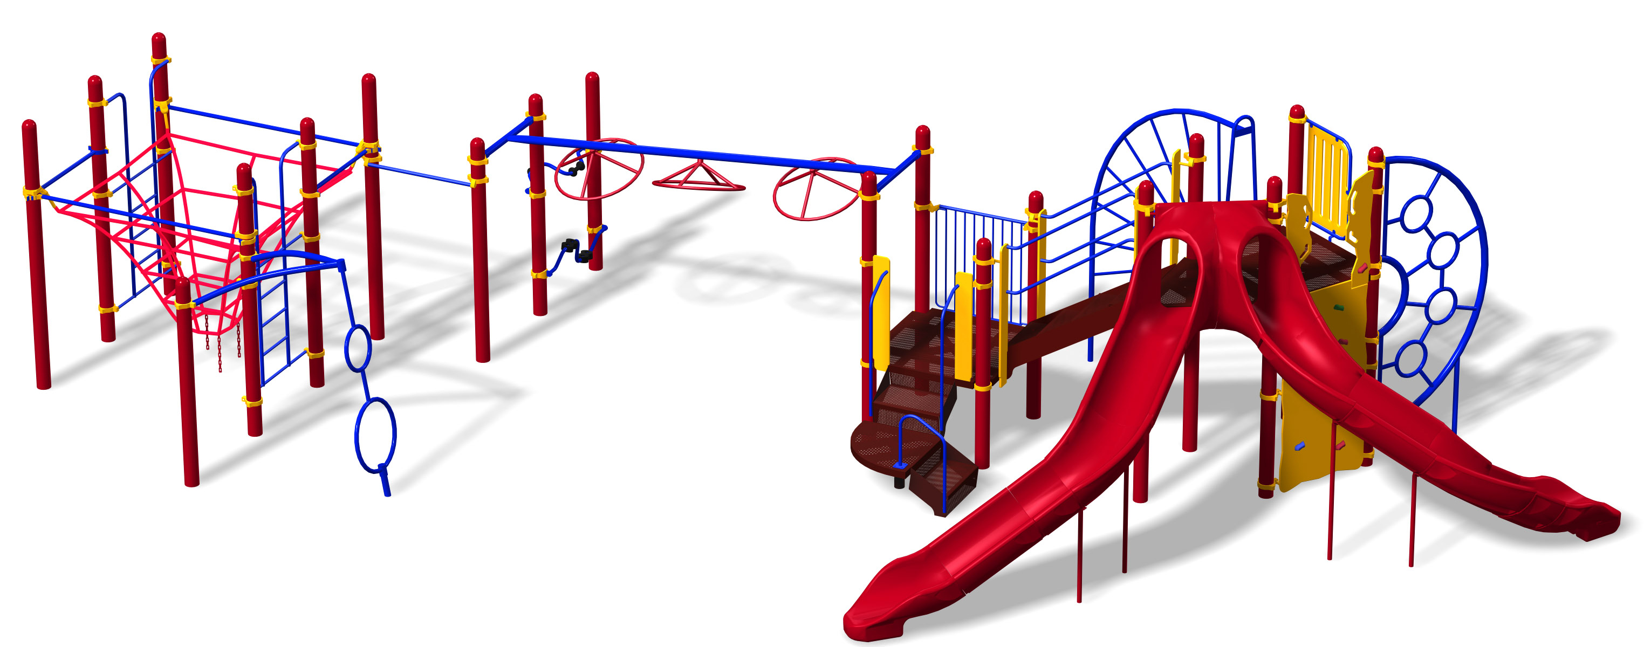
Sincerely,

[Insert appropriate names]
Co-Chairs – [The Playground Project Committee]

Please visit our website for more information on this project,

[www.WRECplayground.org]

